4.1 Socio-demographical characteristics of the participants

**Table 4.1 Socio-demographical characteristics of the participants**

| **Characteristic** | **N = 352** |
| --- | --- |
| **Age** |  |
| < 20 years | 5 (1.4%) |
| 20-24 years | 79 (22%) |
| 25-29 years | 124 (35%) |
| 30-34 years | 76 (22%) |
| 35-39 years | 54 (15%) |
| 40-44 years | 14 (4.0%) |
| **Gender** |  |
| Female | 188 (53%) |
| Male | 164 (47%) |
| **Nationality** |  |
| Nigerian | 352 (100%) |
| **Ethnicity** |  |
| hausa | 85 (24%) |
| Ibo | 67 (19%) |
| Yoruba | 98 (28%) |
| Others (eggon, idoma, Tiv, Igala and Igede) | 102 (29) |
| **Religion** |  |
| Christianity | 188 (53.4%) |
| Islam | 139 (39.5%) |
| Traditional | 25 (7.1%) |
| **Marital Status** |  |
| Divorced | 89 (26%) |
| Married | 178 (51%) |
| Separated | 14 (4.0%) |
| Single | 52 (15%) |
| Widowed | 14 (4.0%) |
| Unknown | 5 |
| **Level of Education** |  |
| Primary | 95 (27%) |
| Secondary | 104 (30%) |
| Tertiary | 143 (41%) |
| Others | 4 (2%) |
| Unknown | 6 |
| **Occupation** |  |
| Employed | 119 (34%) |
| Self-employed | 92 (26%) |
| Unemployed | 141 (40%) |

4.2 Level of awareness among caregivers regarding Nigeria immunization

Table 4.2 Level of awareness among caregivers regarding Nigeria immunization

| **Characteristic** | **N = 352** |
| --- | --- |
| **Have you ever heard of immunization schedule before** | 205 (58%) |
| **if yes to question 9, how did you get to know about Immunization schedule #** |  |
| The Community | 166 (47%) |
| Family/Friends | 157 (45%) |
| Media (television, radio) | 140 (40%) |
| Health personnel | 148 (42%) |
| Other | 157 (45%) |
| **Which vaccine is given at birth #** |  |
| BCG | 171 (49%) |
| Yellow fever | 129 (37%) |
| Rota | 134 (38%) |
| MenA | 135 (38%) |
| Measles | 154 (44%) |
| HPV | 151 (43%) |
| I don’t know | 160 (45%) |
| **What is the recommended age for measles vaccination** |  |
| 12 months | 50 (14%) |
| 22 months | 53 (15%) |
| 6 months | 92 (26%) |
| 9 months | 157 (45%) |
| **At what age are children expected to receive their first immunization** |  |
| 2 weeks after birth | 32 (9.1%) |
| 3 weeks | 46 (13%) |
| At birth | 103 (29%) |
| I dont know | 171 (49%) |
| **Overall Awareness level** |  |
| Poor | 221 (62.8%) |
| Good | 131 (37.2%) |

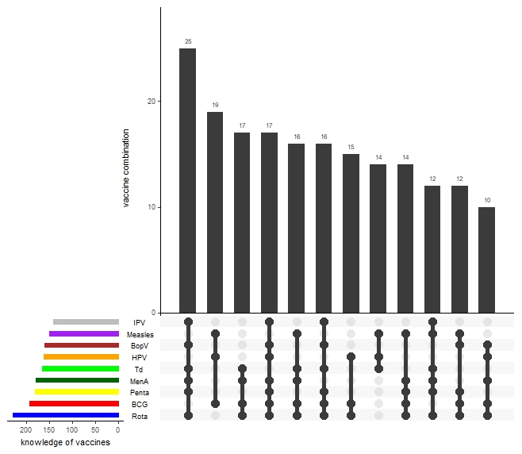

Figure 4.1 Knowledge of available vaccines

**4.3 Frequency of missed opportunity for vaccination among eligible clients**

**Table 4.3 Frequency of missed opportunity for vaccination among eligible clients**

| **Characteristic** | **N = 352** |
| --- | --- |
| **When was your child’s last vaccination** |  |
| < 1 month | 86 (24%) |
| > 1 year | 8 (2.3%) |
| 1-6 month ago | 50 (14%) |
| 7-12 months ago | 33 (9.4%) |
| I dont know | 175 (50%) |
| **Has your child missed any vaccination schedule** | 223 (63%) |
| **If "yes" to 15 above how many vaccination has your child missed** |  |
| 1 | 134 (38%) |
| 2 | 133 (38%) |
| 3 | 55 (16%) |
| 4 | 30 (8.5%) |
| **Do you visit other health facilities to received missed vaccines** |  |
| Yes | 144 (41%) |
| No | 208 (59%) |
| **Have you ever been referred to another health facility for missed vaccines** | 145 (41%) |
| Yes | 145 (41%) |
| No | 207 (59%) |
| **Has there been any recall or reminder for missed vaccinations from your Health facility** |  |
| Yes | 128 (36.4%) |
| No | 224 (63.6%) |

Figure 4.2 Frequency of missed vaccines

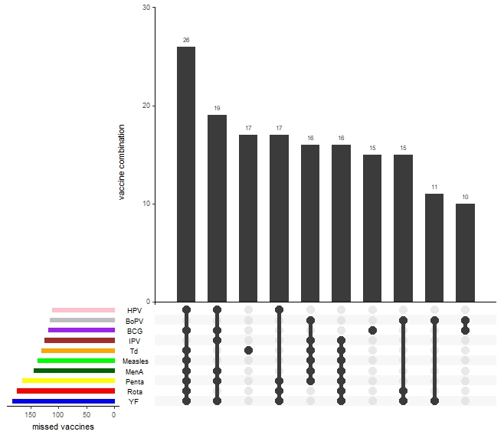

Figure 4.2 Frequency of missed vaccines

**4.4 Drivers for missed opportunity for vaccination**

**Table 4.4 Drivers for missed opportunity for vaccination**

| **Characteristic** | **N = 352** |
| --- | --- |
| **What are challenges you face in assessing vaccination services** |  |
| I. Lack of awareness about vaccination schedules | 221 (63%) |
| II. Stock outs/unavailability of some vaccines | 230 (65%) |
| III. Long waiting hours | 205 (58%) |
| IV. No communication from health workers | 137 (39%) |
| V. Long distance to Health centre | 153 (43%) |
| VI. Cultural believe | 161 (46%) |
| VII Religious beliefs | 128 (36%) |
| VIII No reminder/recall from health centre | 191 (54%) |
| IX Misconception about vaccines | 138 (39%) |
| X Lack of transportation | 136 (39%) |
| XI inconvenient clinic hours | 161 (46%) |
| XII No felt need | 117 (33%) |
| **Does the health facility conducts health talk/ health education on the importance of immunization and other health matters** |  |
| I dont know | 79 (22%) |
| No | 78 (22%) |
| Yes | 195 (55%) |
| **Are you satisfied with the service you receive at the Primary health care center** |  |
| I dont know | 51 (14%) |
| No | 120 (34%) |
| Yes | 181 (51%) |
| **How far is the Primary health center from your home** |  |
| > 30mins from home | 121 (34%) |
| I dont know | 125 (36%) |
| within 30mins from home | 106 (30%) |

|  |  |  |  |  |  |
| --- | --- | --- | --- | --- | --- |
| **What are the antigens missed BCG** | | | | | |
|  | | Frequency | Percent | Valid Percent | Cumulative Percent |
| Valid | Yes | 119 | 33.8 | 33.8 | 33.8 |
| No | 233 | 66.2 | 66.2 | 100.0 |
| Total | 352 | 100.0 | 100.0 |  |

|  |  |  |  |  |  |
| --- | --- | --- | --- | --- | --- |
| **What are the antigens missed Bopv** | | | | | |
|  | | Frequency | Percent | Valid Percent | Cumulative Percent |
| Valid | Yes | 115 | 32.7 | 32.7 | 32.7 |
| No | 237 | 67.3 | 67.3 | 100.0 |
| Total | 352 | 100.0 | 100.0 |  |

|  |  |  |  |  |  |
| --- | --- | --- | --- | --- | --- |
| **What are the antigens missed Penta** | | | | | |
|  | | Frequency | Percent | Valid Percent | Cumulative Percent |
| Valid | Yes | 165 | 46.9 | 46.9 | 46.9 |
| No | 187 | 53.1 | 53.1 | 100.0 |
| Total | 352 | 100.0 | 100.0 |  |

|  |  |  |  |  |  |
| --- | --- | --- | --- | --- | --- |
| **What are the antigens missed Td** | | | | | |
|  | | Frequency | Percent | Valid Percent | Cumulative Percent |
| Valid | Yes | 131 | 37.2 | 37.2 | 37.2 |
| No | 221 | 62.8 | 62.8 | 100.0 |
| Total | 352 | 100.0 | 100.0 |  |

|  |  |  |  |  |  |
| --- | --- | --- | --- | --- | --- |
| **What are the antigens missed, Rota** | | | | | |
|  | | Frequency | Percent | Valid Percent | Cumulative Percent |
| Valid | Yes | 175 | 49.7 | 49.7 | 49.7 |
| No | 177 | 50.3 | 50.3 | 100.0 |
| Total | 352 | 100.0 | 100.0 |  |

|  |  |  |  |  |  |
| --- | --- | --- | --- | --- | --- |
| **What are the antigens missed, MenA** | | | | | |
|  | | Frequency | Percent | Valid Percent | Cumulative Percent |
| Valid | Yes | 145 | 41.2 | 41.2 | 41.2 |
| No | 207 | 58.8 | 58.8 | 100.0 |
| Total | 352 | 100.0 | 100.0 |  |

|  |  |  |  |  |  |
| --- | --- | --- | --- | --- | --- |
| **What are the antigens missed, Measles** | | | | | |
|  | | Frequency | Percent | Valid Percent | Cumulative Percent |
| Valid | Yes | 138 | 39.2 | 39.2 | 39.2 |
| No | 214 | 60.8 | 60.8 | 100.0 |
| Total | 352 | 100.0 | 100.0 |  |

|  |  |  |  |  |  |
| --- | --- | --- | --- | --- | --- |
| **What are the antigens missed, HPV** | | | | | |
|  | | Frequency | Percent | Valid Percent | Cumulative Percent |
| Valid | Yes | 111 | 31.5 | 31.5 | 31.5 |
| No | 241 | 68.5 | 68.5 | 100.0 |
| Total | 352 | 100.0 | 100.0 |  |

|  |  |  |  |  |  |
| --- | --- | --- | --- | --- | --- |
| **What are the antigens missed, IPV** | | | | | |
|  | | Frequency | Percent | Valid Percent | Cumulative Percent |
| Valid | Yes | 125 | 35.5 | 35.5 | 35.5 |
| No | 227 | 64.5 | 64.5 | 100.0 |
| Total | 352 | 100.0 | 100.0 |  |

|  |  |  |  |  |  |
| --- | --- | --- | --- | --- | --- |
| **What are the antigens missed, YF** | | | | | |
|  | | Frequency | Percent | Valid Percent | Cumulative Percent |
| Valid | Yes | 183 | 52.0 | 52.0 | 52.0 |
| No | 169 | 48.0 | 48.0 | 100.0 |
| Total | 352 | 100.0 | 100.0 |  |

**Table 4.2.2 The association of the level of awareness of immunization among participants with socio-demographic factors**

| Sociodemographic | Poor Awareness | Good Awareness | Chi-square | P-value |
| --- | --- | --- | --- | --- |
| **Age category** |  |  | 21.358 | 0.001* |
| < 20 years | 2 (40%) | 3 (60%) |  |  |
| 20-24 years | 53 (67.1%) | 26 (32.9%) |  |  |
| 25-29 years | 75 (60.5%) | 49 (39.5%) |  |  |
| 30-34 years | 36 (47.4%) | 40 (52.6%) |  |  |
| 35-39 years | 46 (85.2%) | 8 (14.8%) |  |  |
| 40-44 years | 9 (64.3%) | 5 (35.7%) |  |  |
| **Gender** |  |  | 1.238 | 0.158 |
| Male | 108 (65.9%) | 56 (34.1%) |  |  |
| Female | 113 (60.1%) | 75 (39.9%) |  |  |
| **Religion** |  |  |  |  |
| Christianity | 113 (60.1%) | 75 (39.9%) | 32.613 | <0.001* |
| Islam | 104 (74.8%) | 35 (25.2%) |  |  |
| Traditional | 4 (16%) | 21 (84%) |  |  |
| **Marital status** |  |  | 30.653 | <0.001* |
| Single | 22 (42.3%) | 30 (57.7%) |  |  |
| Married | 128 (71.9%) | 50 (57.7%) |  |  |
| Divorced | 49 (55.1%) | 40 (44.9%) |  |  |
| Widowed | 5 (35.7) | 9 (64.3%) |  |  |
| Separated | 14 (100%) | 0 (0%) |  |  |
| **Education level** |  |  | 10.886 | 0.012* |
| Primary | 64 (67.4%) | 31 (32.6%) |  |  |
| Secondary | 77 (74.0%) | 27 (26.0%) |  |  |
| Tertiary | 78 (54.5%) | 65 (45.5%) |  |  |
| Others | 2 (50%) | 2 (50%) |  |  |
| **Occupation** |  |  | 1.935 | 0.380 |
| Employed | 80 (67.2%) | 39 (32.8%) |  |  |
| Unemployed | 83 (58.9%) | 58 (41.1%) |  |  |
| Self-employed | 58 (63.0%) | 34 (37.0%) |  |  |

*-significant at p-value < 0.05

Table 4.2**.3 Multivariate analysis of the level of awareness of immunization among participants with socio-demographic factors**

|  |  |  |  |  |  |  |
| --- | --- | --- | --- | --- | --- | --- |
| Variables | Odd ratio | p-value | 95%CI | Adj. OR | p-value | 95%CI |
| **Age category** |  |  |  |  |  |  |
| < 20 years | 2.700 | 0.353 | 0.332-21.97 | 7.408 | 0.095 | 0.708-7.741 |
| 20-24 years | 0.883 | 0.838 | 0.269-2.90 | 1.742 | 0.419 | 0.4536-6.697 |
| 25-29 years | 1.176 | 0.782 | 0.372-3.71 | 1.925 | 0.353 | 0.483-7.678 |
| 30-34 years | 2.000 | 0.251 | 0.613-6.52 | 2.607 | 0.161 | 0.683-9.941 |
| 35-39 years | 0.313 | 0.086 | 0.083-1.179 | 0.439 | 0.282 | 0.098-1.970 |
| 40-44 years | 1 (ref) |  |  | 1 (ref) |  |  |
| **Religion** |  |  |  |  |  |  |
| Christianity | 2.126 | <0.001 | 0.042-3.83 | 3.112 | 0.001 | 0.032-0.391 |
| Islam | 2.064 | <0.001 | 0.021-3.01 | 3.098 | 0.000 | 0.029-0.333 |
| Traditional | 1 (ref) |  |  | 1 (ref) |  |  |
| **Marital status** |  |  |  |  |  |  |
| Single | 2.202 | <0.001 | 0.881-4.352 | 5.953 | <0.001 | 0.532-5.111 |
| Married | 6.311 | <0.001 | 1.367-10.251 | 10.836 | <0.001 | 2.850-13.866 |
| Divorced | 1.318 | <0.001 | 0.038-4.991 | 1.849 | <0.001 | 0.687-9.008 |
| Widowed | 2.907 | <0.001 | 1.912-8.762 | 7.967 | <0.001 | 1.802- 12.551 |
| Separated | 1 (ref) |  |  | 1 (ref) |  |  |
| **Education level** |  |  |  |  |  |  |
| Primary | 0.484 | 0.479 | 0.484-3.602 | 0.131 | 0.157 | 0.008-2.185 |
| Secondary | 0.351 | 0.306 | 0.351-2.613 | 0.108 | 0.121 | 0.006-1.797 |
| Tertiary | 1.833 | 0.857 | 0.833-6.081 | 2.446 | 0.566 | 0.028-7.019 |
| Others | 1 (ref) |  |  | 1 (ref) |  |  |